MedCommons Network

MedCommons is a trusted national network for access to selected diagnostic studies from any device in any hospital or imaging center by patients, physicians, and service providers in a standard, secure and FDA/HIPAA compliant manner. The network supports multiple clinical applications including second opinions, night radiology, computer aided diagnostics, drug and device trials, patient follow-up and treatment planning. MedCommons will ensure compatibility with all current and emerging IHE (Integrated Healthcare Enterprise) standards and profiles as a means of future proofing our customers investment in a heterogeneous vendor environment.

MedCommons is built upon existing Open Source and Web Services software, , achieving FDA compliance through the use of peer-reviewed open source software methods. We will introduce a remotely managed MedCommons Hardware Appliance that can plug into any existing hospital LAN and serves as a platform for introducing progressively richer software enabled functionality in a HIPAA and IHE compliant platform for universal global access to DICOM and HL7 diagnostic studies.

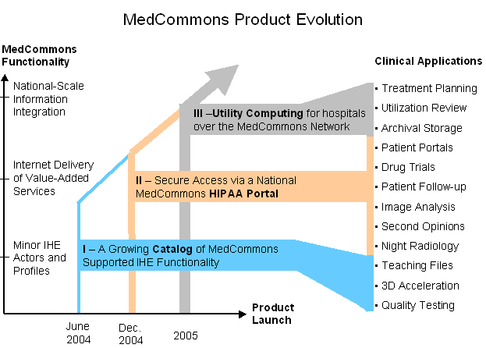
The appliance is constructed as Open Source and will be available under standard licensing terms and is absolutely free for non-commercial use. For MedCommons this affords an easier road to regulatory approval as the FDA and HIPAA are encouraged by transparency and use of proven off the shelf protocols and it is also a means to offer a higher quality set of products, as a wide array of contributors and critics can build a better platform that any single company. For hospitals, imaging centers, and other modality customers it affords a vendor neutral architecture, allowing a level playing field with more choice and lower switching costs. MedCommons supports a plug-in architecture to allow proprietary extensions to be added to the open source codebase by 3rd parties and ourselves. Our expectation is that most extensions will be contributed back to the community.
The MedCommons business model is similar to RedHat and Novell/SUSE who have successfully commercialized the open source Linux operating system. We will make money selling and remotely servicing appliances that are installed in each enterprise. We will sell software kits to device manufacturers and other software vendors that want to extend or modify the code. Our intention over time is to build transaction fee based services for the safe storage and transport of and real-time access to studies and to foster the development of multiple higher order services based upon the MedCommons platform in a sustainable manner that fits within existing FDA medical device regulations and within the Integrated Healthcare Enterprise profiles. To ensure interoperability across a diverse base of vendors and technologies we will construct a simulator and testing environment that can measure conformance to applicable standards.
The Market
The market for diagnostic studies includes radiology images and laboratory tests. The lab test market includes blood tests, pathology images and the emerging genomics and proteomics scans. Each of some 10,000 sites that produce over 100 million high-resolution (CT, MR, Mammography) digital scans in the US is a candidate to install a MedCommons Appliance Over 200,000 surgeons, radiologists, other specialists and most primary care physicians have the potential to access any MedCommons studies directly over the Web or indirectly through their PACS or electronic medical record workstations. (See attached summary spreadsheet for additional details).
As appliance functionality grows and early adopters in a large hospitals are successful in deploying MedCommons, our business will hit a tipping point as medium and small Hospitals and Imaging Centers will realize the need to be on the network as well. As more physicians realize that they will have easier access to patient images that available over the MedCommons Network, they will naturally route their patients to appropriately configured centers. The Pharmas and CROs, realizing that they can more readily track with absolute security and reliability at a lower cost will prefer the MedCommons network to current custom film based practices. The fact that we will shave months off of the current process will be a great driver for adoption. Insurers will prefer imaging centers that are on MedCommons, as the cost of doing business is dramatically reduced.

Product and Service Summary
To run and service the network, MedCommons establishes a point of presence behind the firewall at every imaging center or hospital to facilitate networking, local storage, management. The OSS Appliance Kernel is constructed from existing off the shelf open source software written by various industry and academic contributors and additional software contributed by MedCommons. The appliance kernel can be loaded and run on commodity hardware, or fashioned into an appliance, or embedded into a PACS or scanner. The primary functions of the appliance kernel are to handle local image storage and transfers to and from other appliances, and to implement the IHE actors that ensure compliance. The appliance allows extensions to be written by 3rd parties as plug-ins.
A managed Medcommons Appliance, built on the DICOM OSS appliance kernel will be deployed on every participating modality LAN as a gateway between the hospital LAN and the MedCommons Network. The appliance uses DICOM to select images that are of interest to the network, storing them locally and eventually participating in the transfer and storage of these in other appliances at other institutions. The appliance adds both remote and local user administrative interfaces as well as additional security features to the basic open source package
Initially MedCommons will focus on building a complete catalog of IHE actors and profiles, and will commence development work on five products and services built as extensions to the appliance: the Archiving and Disaster Recovery service keeps images forever at multiple offsite locations in vendor neutral form, and provides alternate execution sites in event of hospital rispacs failure; 3d Accelerator is a customized cache that achieves 5x rendering improvement for complex datasets; Clinical Trial Assist tracks studies on patients over time with associated information management support; Image Analysis/Cad Platform which supports automated machine diagnosis; and Pacsalyzer Tester and appliance that exercises PACS and RIS systems for IHE and DICOM compatibilities
Over time we will introduce a series of value added services over the internet, including HIPAA/IHE Secure Logging and a secure web based Patient Portal, One or more MedCommons Portals monitor and control the appliances, coordinating synchronized appliance to appliance secure image transfers across institutional firewalls according to schedules or on demand. Thus, the appliances function as local buffers within a hospital, and will typically have storage for a week's worth of images. A portal, responding to Web Service requests from an Application Service, checks entitlements and rights and then gets the two appliances to transfer a particular set of images. The User Interface for the MedCommons Portal is re-brandable and easily localized and internationalized.. The MedCommons Portal is built upon proprietary code and represents fundamental unique intellectual property of MedCommons. It contains no GPL or other open source code that would force us to redistribute the portal software.
DICOM Studio permits IHE compatible viewing of images and manipulation of image metadata on any appliance or storage server on the MedCommons Network. We will assemble the DICOM Studio based on the open source Dicom Viewers and the Eclipse Modeling Framework. By utilizing Eclipse, DICOM Studio will allow for the eventual migration of advanced workstation functionality into an open source environment.
Benefits of Participation in the MedCommons Network (not sure if we need or want this)
- FDA, HIPAA, and HIPAA Compliance. Our software development and integration process has been organized to ensure that all requirements for approval from these organizations are fulfilled.
- Reduced time for clinical trials with greater precision in patient tracking and followup. This has the potential for saving huge amounts of money, and will prevent costly errors requiring data interpolation.
- Storage service(s) supply neutral repositories for personal imaging, facilitating second opinion services. These repositories will be maintained by other service providers.
- Data Suppliers enjoy higher accuracy and lower cost delivery of anonymized diagnostic studies. This is much easier and lower cost that burning CDs.
- Free access for Patients and Physicians. This drives demand for MedCommons appliance installation at hospitals and imaging centers , those patients who wish to make use of every option available for their own healthcare decisions will be able to control their interaction with physicians, pharmaceutical and medical device companies to a greater extent than ever before.
- Easy to use Web Services Platform for service providers. Makes it a snap to embed any of the MedCommons platform functions in a higher order service
- Embedded Billing and Branding services. Branding allows various channel partners the opportunity to rebrand MedCommons to serve the need of a particular market. Billing services allow 3rd parties and channel partners the opportunity to have MedCommons handle as part of unified monthly statement
- Open Source Appliance Kernel. Anyone can hook to the network by utilizing the basic code contributed by MedCommons. However, connection to the MedCommons Portal will require passing the appropriate certification suites.
- Reduction of Unnecessary Therapy - The founders of MedCommons believe that increased access to open, objective, peer-reviewed medical diagnostics in a structure that facilitates patient control will improve outcomes and reduce health care costs. The principal mechanism for these improvements is a reduction in the amount of inappropriate and unnecessary therapy that some studies claim wastes up to 30% of total health care expenditures

